CSV Java Report

By: Ryan Nguyen

Abstract:

This report is a step by step documentation of how I learned to program the plotter, salter, and smoother using Java. I used various resources to help me along the way. The final results are presented in the google sheets link here: [CSV Java Report Plotter Salter Smoother](https://docs.google.com/spreadsheets/d/1puDbtPA5JEGgyl3eA-mJz0gxYwUjs8nO_Hm1z8pY_A0/edit#gid=0)

## Plotter

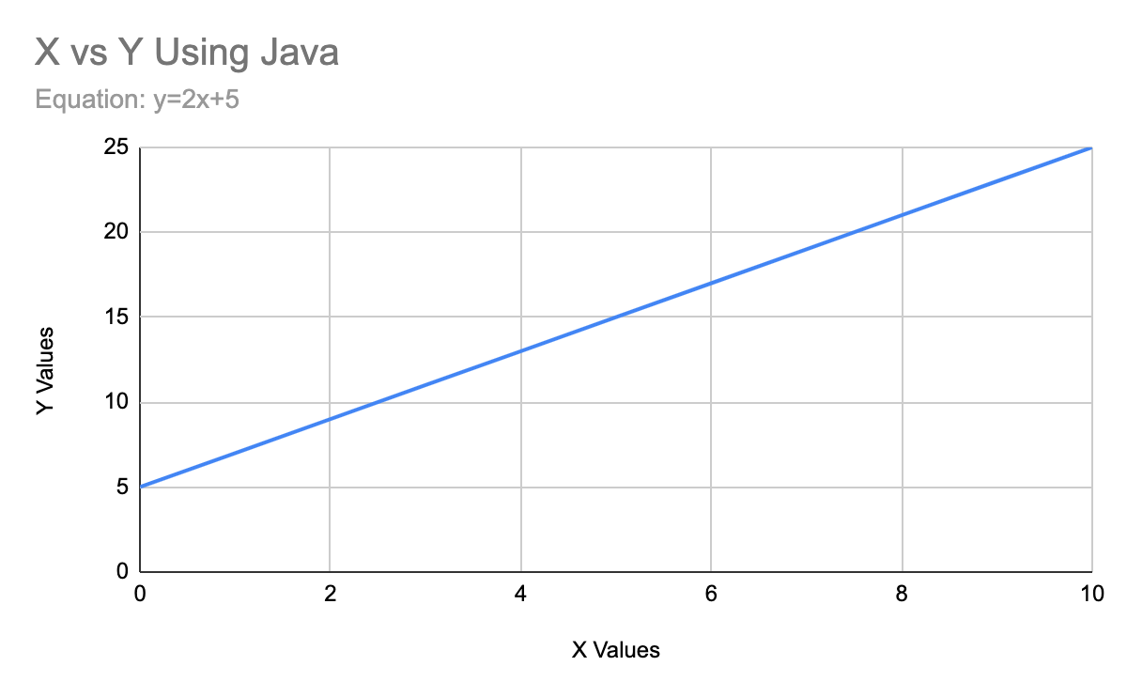

The first thing I did was think of an equation. The equation I wanted to use was y=2x+5 and I wanted the x range to be from 0 to 10. I started the coding by making a for loop that would go from 0 to 10 and produce the equation’s y values. The hard part of the plotter was learning the CSV file and how to produce one. Using this video [How to Read and Write CSV files in Java using Eclipse IDE](https://www.youtube.com/watch?v=1sCgEKAp-lU) I learned we needed to use PrintWriter to make the csv file. Using their constructor I was able to add all the xValues and yValues from the dataset to extract the LinearDataGraph.csv file.

## Salter

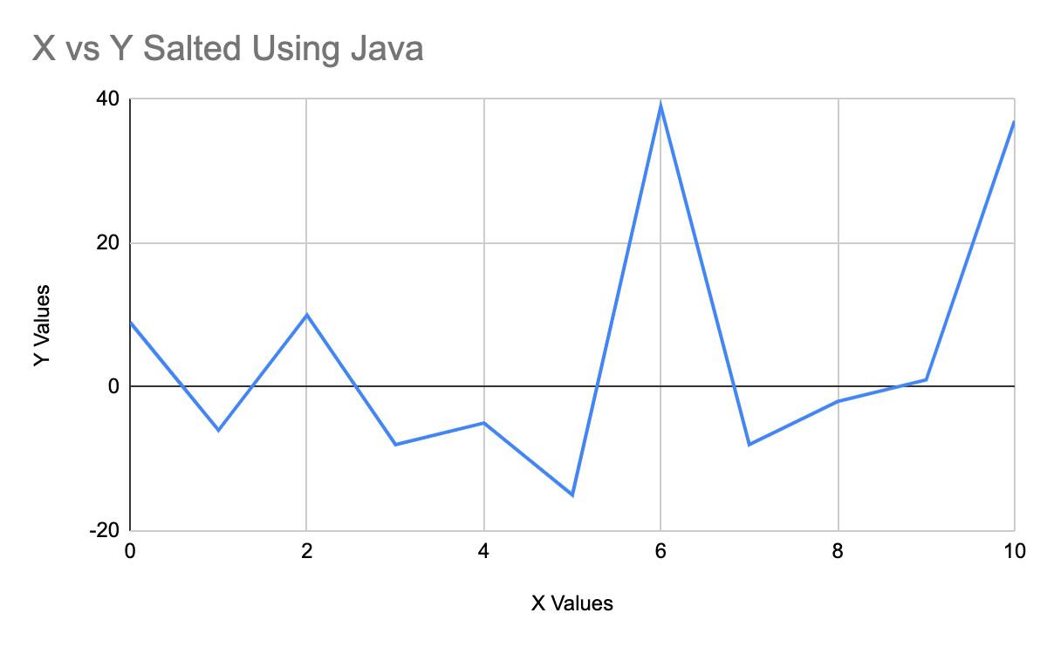

The salted dataset was a little more difficult because I started the program not knowing how to read a csv file, but again using [How to Read and Write CSV files in Java using Eclipse IDE](https://www.youtube.com/watch?v=1sCgEKAp-lU) I learned how to read line by line out of the LinearDataGraph.csv file I created in the plotter. Using the reader I added the randomizer to salt the data by 30. The difficult part of the salting program was how to input the data back into the graph in the correct format after changing the values but I figured it out, it was just a simple for loop.

## Smoother

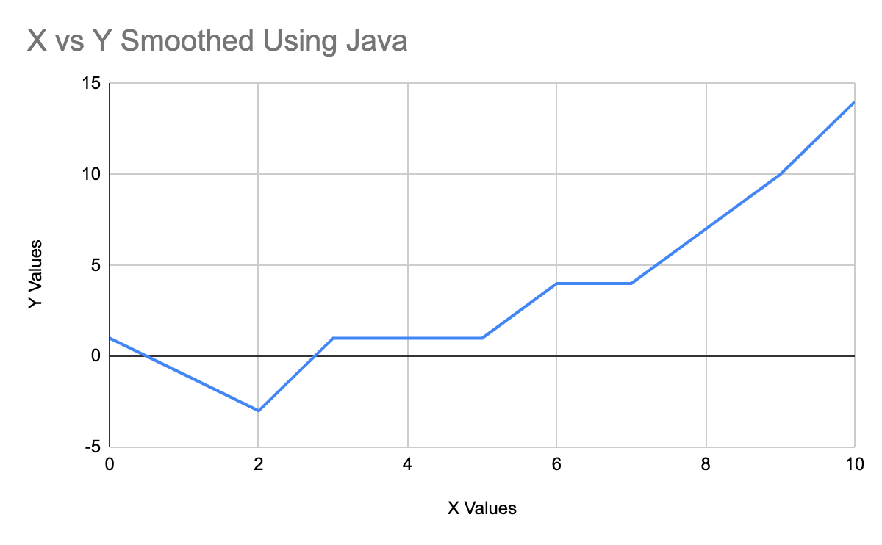

The smoother was definitely the hardest part of this report because I understood the concept and the thought process, but I didn’t know how to put it in code. Learning how to read and write csv files made that part of the program easy, but finding the mean around the window of the index was difficult when the index was near the beginning and the end. Figuring that out was satisfying.

## Combined Graphs

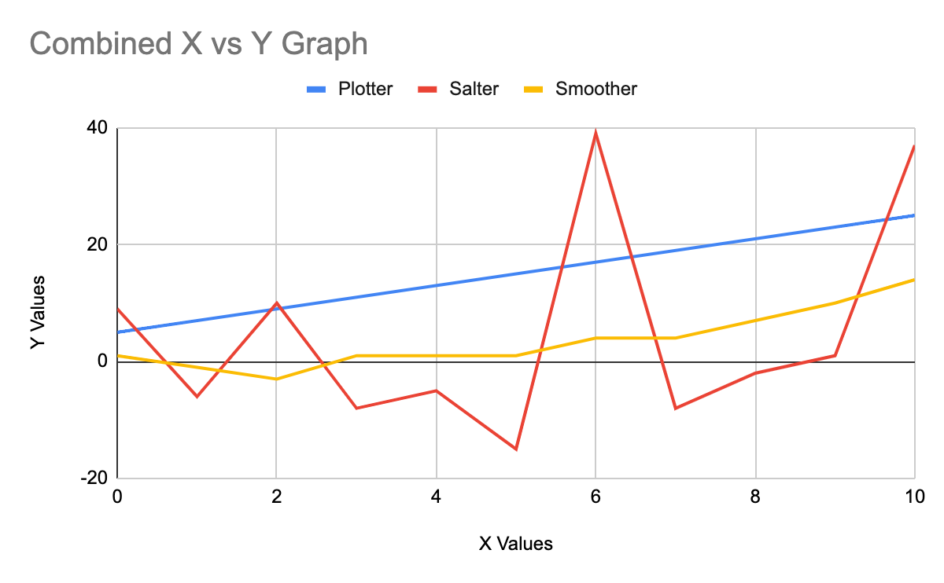

As you can see within the combined graphs, the standard linear graph of the plotter is correctly inputted. The salted version of the plotter is correct because all the values are within a -30 to 30 range added towards the linear graph. The smoother is correct because of the smoother trend line going through the salted graph’s line.